1. 
2. 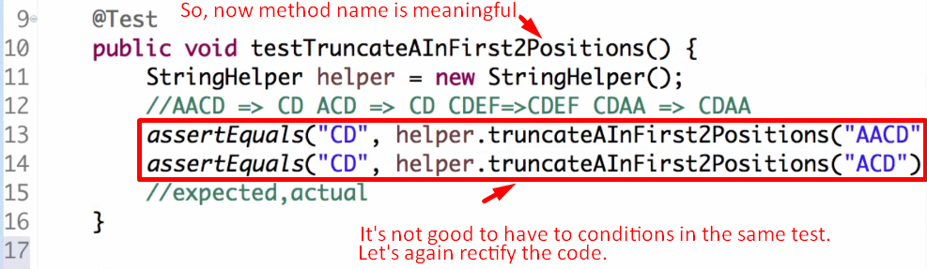
3. **NOTE**: Test Method should be public void otherwise error.
   1. **Why**? Some frameworks call test methods and they are in different packages.
4. 